Dear [EFFICIENCY PROGRAM CUSTOMER],

We’re excited to share some important news affecting our commercial and industrial (C&I) energy efficiency programs. As you’re likely aware, LED technology has transformed lighting over the past decade, allowing companies and organizations to save more energy than ever before. We are proud to provide incentives to our C&I customers to encourage these energy savings. To ensure we are spurring the installation of products that are not only energy efficient, but also meet the high-quality lighting needs of a variety of workplace environments, we rely on effective third-party product vetting. To that end, we depend on the science-based solid-state lighting policies set and updated regularly by the [DesignLights Consortium](http://www.designlights.org) (DLC).

On February 14, 2020, the DLC released the latest version of its [Solid-State (SSL) Technical Requirements](https://www.designlights.org/solid-state-lighting/qualification-requirements/v5-transition/). Taking effect in two phases (V5.0 and V5.1), the requirements put new emphasis on the “quality of light” produced - attributes such as color performance, glare, and light distribution, which have been shown to improve user satisfaction, comfort, mood, and safety. Under the new policy, qualifying products for the DLC’s Qualified Products List ([QPL](https://www.designlights.org/search/)) – which informs our C&I efficiency programs – will require added attention to these characteristics. The policy also increases the energy efficiency benchmarks for products on the QPL.

V5.0, the first of the two new policies, went into effect on February 18, 2020, and focuses on energy savings by increasing efficacy requirements for QPL product listings with the pace of technology. It also moves the LED market in a more controls-focused direction by adding dimming capability requirements for most indoor luminaires and retrofit kits, as well all DLC Premium products. Making the ability to dim a requirement for the QPL locks in potential energy and costs savings for years to come, since LEDs installed today might not be replaced for another decade.

V5.1 takes effect in July 2020, and establishes requirements and reporting for lighting characteristics such as color performance, glare, and light distribution in order to provide better quality of light for people living and working in the built environment. Additionally, dimming requirements and reporting on integral controls and control protocols of dimmable DLC-listed products, including indoor lamps and exterior luminaires, will unlock even more energy savings and will help users identify product compatibility with lighting control systems.

Because additional product testing and design changes may be needed to meet these requirements, the DLC has built in grace periods to update products listed on the QPL.

Products that are delisted from the DLC QPL may not be eligible for incentives, so it is important that trade allies verify that products being installed will remain qualified at the time an incentive application is submitted to the program. To avoid selling products that may not be eligible for incentives, distributors should verify status with manufacturers and exercise caution when stocking products that are not updated to V5.0 in 2020, and to V5.1 in 2021. V4.4 products may not be eligible for rebates in 2021.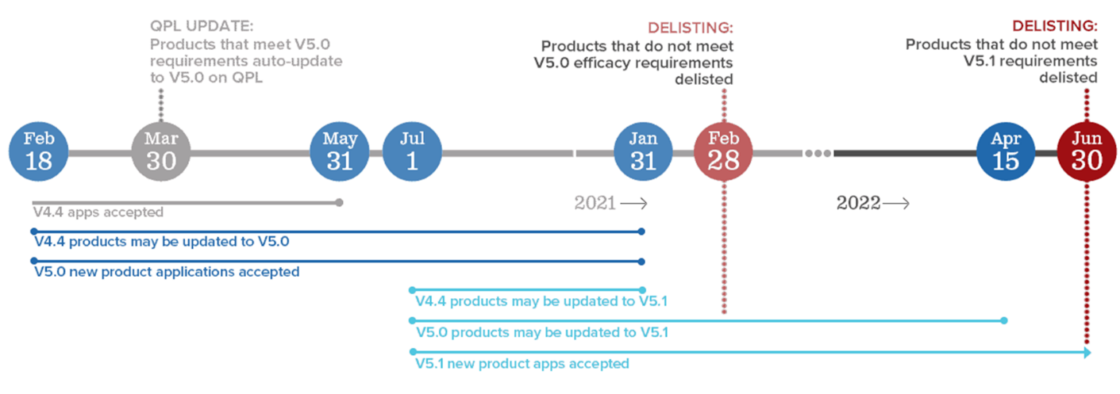

***Products that are delisted from the DLC QPL may not be eligible for incentives, so it is important to verify that products being installed will remain qualified at the time an incentive application is submitted to the program.***

The DLC has provided [Manufacturer and Industry Guidance](https://www.designlights.org/solid-state-lighting/qualification-requirements/v5-transition/manufacturer-guidance) with the new SSL Technical Requirements policy release, and will host a recorded [webinar](https://www.designlights.org/news-events/webinars/ssl-technical-requirements-v5-0-and-v5-1-overview-webinar/) on February 20, 2020 to provide more information and answer questions about the policies.

As always, we are available to answer any additional questions you may have about this new policy and how it affects your business, and we look forward to working with you during this transition.